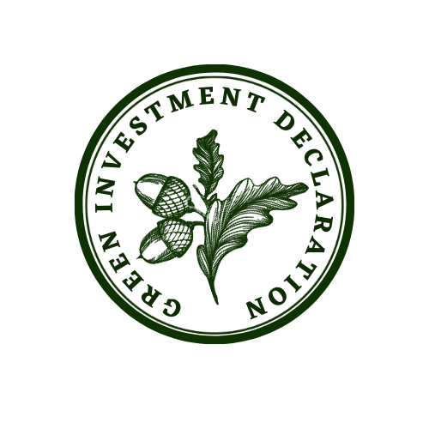
A Sample Talk to Church Leadership / Synods / Councils
on The Green Investment Declaration

Thank you for giving me the opportunity to speak with you today about an important initiative: the Green Investment Declaration, launched by Operation Noah and the JustMoney Movement.

1. The Urgency of the Climate Crisis
The climate crisis is the most urgent challenge of our time. Scientists warn us that if we do not act decisively, the effects of global warming—rising sea levels, extreme weather, and loss of biodiversity—will worsen dramatically.
The poor and vulnerable are disproportionately affected by climate change making this not only an environmental crisis but also an issue of justice.
As Christians, we are called to respond. And while the church has responded well to the challenge of reducing our own environmental impact, there is an urgent missional need for the church to be tackling the climate crisis with all the resources she has. Our particular focus here is on how we might use the Church’s financial resources for this mission.

2. The Biblical Imperative
The Green Investment Declaration is founded on our calling to care for God’s creation, live out the commands of love and justice, and it provides an opportunity for the church to speak and act prophetically and inspire hope.
- Care for God’s Creation
In the creation story in Genesis humans are given a special role in God’s creation to have ‘dominion’ or ‘rule’ over all creation. The mandate is not to exploit and extract as we have done but to ‘work it and take care of it’ (Gen 2:15 NIV).
Many churches have chosen to divest from practices that harm the earth, however by investing in climate solutions the Church can go beyond ‘doing no harm’ to actively promoting care for God’s creation.

Love your neighbour

Jesus said the greatest commandment is to love God and love your neighbour as yourself. The parable of the Good Samaritan makes clear that the definition of ‘neighbour’ can include anyone. Paul writes, “Love does no wrong to a neighbour; therefore, love is the fulfilling of the law” (Romans 13:10).

Climate change disproportionately affects vulnerable communities, particularly the poorest in the world. These communities include inhabitants of low-lying island states, communities in areas affected by extreme weather events such as hurricanes, flooding and drought and communities that do not have the financial resources to develop resilience. In a global community, these people are our neighbours, and we are called to love them. By investing in solutions that protect and sustain these communities we can show practical love and solidarity.

- Justice for everyone

The climate crisis is an issue of justice. There is injustice across the world in terms of impact and resilience as well as cause: Nations who have contributed the least in terms of carbon emissions are those most adversely affected and while the West has benefited enormously from a fossil fuel powered economy, those benefits have not been distributed equally across the world.
What does God require of us? In the words of Micah, it is to “act justly, love mercy and walk humbly with God” (Micah 6.8). “To do righteousness and justice is more acceptable to the Lord than sacrifice” (Prov 21:3).
The church needs to ensure that our money and investments are not playing their part in a system of injustice. Just as it is important to ensure our investments are not causing harm, the finance world also needs moral leadership to ensure the transition to a green economy happens in a way that is just and does not replicate the moral failings of the last few hundred years. There is a huge opportunity for climate solutions to tackle fundamental issues of poverty, equity and human rights if we choose to do so.

A Prophetic Church

The church is called to be prophetic. One important way the church can be prophetic is in how it chooses to use its assets and financial resources. The decision of many churches to divest from fossil fuels was a powerful prophetic act. In turn, by investing in climate solutions the church can act equally prophetically and use its voice to speak up and amplify the urgency of moving to a low carbon economy. It can also play an important role in shaping the conversation and provide moral leadership about how we as a global community transition to a low-carbon economy.

New Creation and the Ministry of Reconciliation
Christian hope is in a restored, redeemed and renewed heaven and earth. The church is also called to a ministry of reconciliation:
Therefore, if anyone is in Christ, the new creation has come: The old has gone, the new is here! All this is from God, who reconciled us to himself through Christ and gave us the ministry of reconciliation (2 Corinthians 5: 17-18).
This message of reconciliation that has been entrusted to us includes ministry to all of God’s creation.
Financial assets are one of God’s gifts to his church to enable us to fulfil the ministry of reconciliation and investing in activity that protects, nourishes and blesses all of life is one way of fulfilling this calling. Furthermore in this time of climate crisis it is imperative that the church invests its money in activity that focuses on the most effective ways to protect and sustain both human life and nonhuman creation.

3. The Green Investment Declaration
The Green Investment Declaration provides a practical way for churches to act. It encourages the church to shift investments toward climate solutions such as renewable energy, sustainable agriculture, and nature-based solutions.
It also aims to build momentum and create a movement towards financing climate solutions. By signing the Green Investment Declaration and communicating publicly about it, churches and faith organisations are sending out a strong signal to the rest of the investment world and society more generally about the urgent need to finance the transition to a green economy.
This declaration has three levels of commitment:
- Acorn Stage: Commit to embedding climate-positive policies into investment strategies.
- Sapling Stage: Actively invest in climate solutions and plans for increasing investments.
- Oak Stage: Already invested at least 5% of assets in climate solutions with plans for further investments.

4. Next Steps
What actions can we as a church take?
- Evaluate Current Investments: Work with the finance team to understand how the current investments align—or do not align—with our values.
- Seek advice: It’s important to begin a conversation with the investment managers as soon as possible to explore what options are available for investing in climate solutions. You may wish to seek advice from an external investment consultant. It also may be necessary to consider switching to alternative investment managers if your existing funds do not align with your values.
- Review the investment policy to ensure the stipulations of the Green Investment Declaration are embedded in policy statements.
- Commit to Change: Agree to signing the Green Investment Declaration and setting achievable goals for increasing climate-positive investments.
- Sign the GID and publicly communicate: Communicate the green investment policy to churches and other organisations.

Conclusion
In closing, signing the Green Investment Declaration is a way for our church to put faith into action and fulfill our calling to care for creation, act justly and inspire hope in the face of the climate crisis.
I urge us to prayerfully consider joining this movement.
Thank you.

