Campaigning Letter Template

Please feel free to use and adapt this template to write to your Diocese / Synod / Finance Board and Church Leaders to encourage them to consider joining the Green Investment Declaration.

You may wish to send it round to your contacts and include a number of signatories.

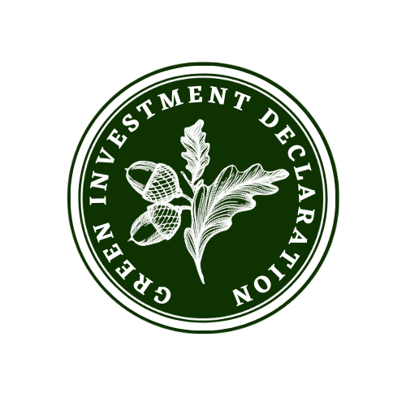

Dear

Making money work for God’s creation

We know that money has power. We also know that power can either be harnessed for good or used to fuel harm, so we believe we should think carefully about how we make money work for the benefit of God’s creation.

We were therefore delighted with the [Faith Organisation / Synod / Diocese]’s decision to Divest from Fossil Fuels in [enter date ]. This sent a strong signal to the Fossil Fuel industry and to the wider world that we can no longer be part of a system that harms our planet.

We also applaud how our [Faith Organisation / Synod / Diocese] has taken significant actions to reduce our own carbon footprint and the work being done towards achieving Net zero by 2030.

However, we believe that we must do more.

While it is important to take steps to mitigate our own footprint, there are opportunities to take positive action in tackling the climate crisis and being part of the solution. Indeed, the technology and climate solutions already exist to prevent climate catastrophe.

We have the agency to make the necessary changes, we now need the urgency.

And we believe the Church has a Divine mandate to play a vital leadership role in restoring Creation.

We are therefore writing to encourage the [Faith Organisation / Synod / Diocese] to consider signing up to the Green Investment Declaration - a joint initiative by JustMoney Movement and Operation Noah.

The Green Investment Declaration encourages faith institutions to commit to investing in Climate Solutions and making the following public commitment and declaration:

We believe that as a faith organization, we have the moral obligation to be advocates
for climate, nature and humanity, which are all impacted by the climate crisis. We
believe that our actions must help build a society that is just for all. We therefore
believe that it is our responsibility to align our investments with our faith values and
move beyond negative screening to consider how our investments actively fund climate
solutions to create positive social and environmental impacts. By signing this declaration, we acknowledge the importance of being on an investment journey to build a more just world for both people and the planet

To find out more you can visit: operationnoah.org/investment.

The Climate Crisis is the most urgent crisis of our time. The Green Investment Declaration is an important step that Churches can make in restoring God’s creation and we would love you to consider joining the movement.

Yours sincerely,

[List of Signatories / Name of Organisation or Group]

https://collab.faithinvest.org/green-investment-declaration

